**Welcome to Advanced Web Engeeneering(AWE) Product List:**

**Component 2:**

**Web Application:**

**Introduction:**

A web application is a computer program that performs tasks over the Internet using web browsers and web technologies. A web application is a client-server program. It means that it has a client-side and a server-side. The term "client" here refers to the program the individual uses to run the application. It is part of the client-server environment, where many computers share information. For example, in the case of a database, the client is the program through which the user enters data. The server is the application that stores the information.

Businesses need to exchange information and conclude transactions with their target customers. The Internet can be an excellent and inexpensive channel for that purpose, providing that there is a way to capture and store all the necessary data and show results to users. Thanks to web applications, users can interact with the business using shopping carts or content management systems.

Web apps can be developed for many different reasons and used by companies or individuals. Individuals need it to facilitate their communication or purchase things online. Also, employees can collaborate on projects and work on shared documents with web applications. They can create reports, files, and share information from anywhere and with any device.

## **Benefits of web applications**

A web application has many benefits, including:

* You don't need to install on the hard drive, so it doesn't cause space limitations.
* It requires less support and maintenance from the business and lower technical requirements from the user's computer.
* A web application reduces costs for both the end-user and the business.
* Web applications are always up to date because updates are applied centrally.
* All users can access the same version so it eliminates any compatibility issues.
* You can access web applications anywhere with a web browser

## **How does a web application work?**

All you need to access a web app is an internet connection. You use a web browser like Safari, Mozilla Firefox or Google Chrome to connect to your app. There are three elements the web application requires to function: a web server to handle requests from the client, an application server to execute the tasks requested and a database to store the information.

server-side processing. They are called "dynamic". Some don't need processing at the server-side and are static.

Here is how a web application works:

1. The user creates a request to the web server over the Internet through the application's user interface.
2. The web server sends this request to the web application server.
3. The web application server executes the requested task, then generates the results of the required data.
4. The web application server sends those results back to the web server (requested information or processed data).
5. The web server carries the requested information to the client (tablet, mobile device or desktop).
6. The requested information appears on the user's display.

**For component 2 final output are in the given screenshot:**

In this task we need to develop the web application using cmd promt, php, converting the file into laravel.

Step 1:

In this part I have install xampp and varavel from the cmd prompt which I have shown in scrrenshot.

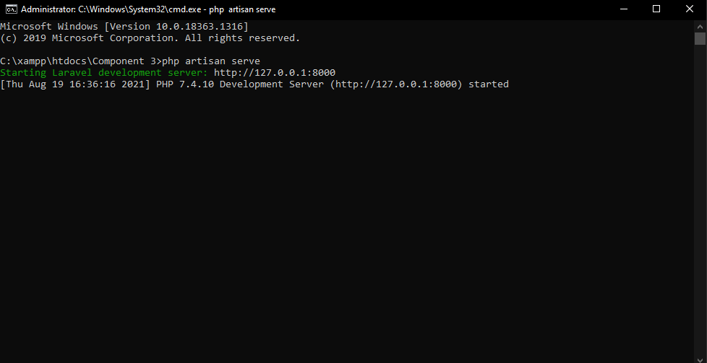

Step 2:

In this part we can add books cds and the the final create show the output which we have to write there.

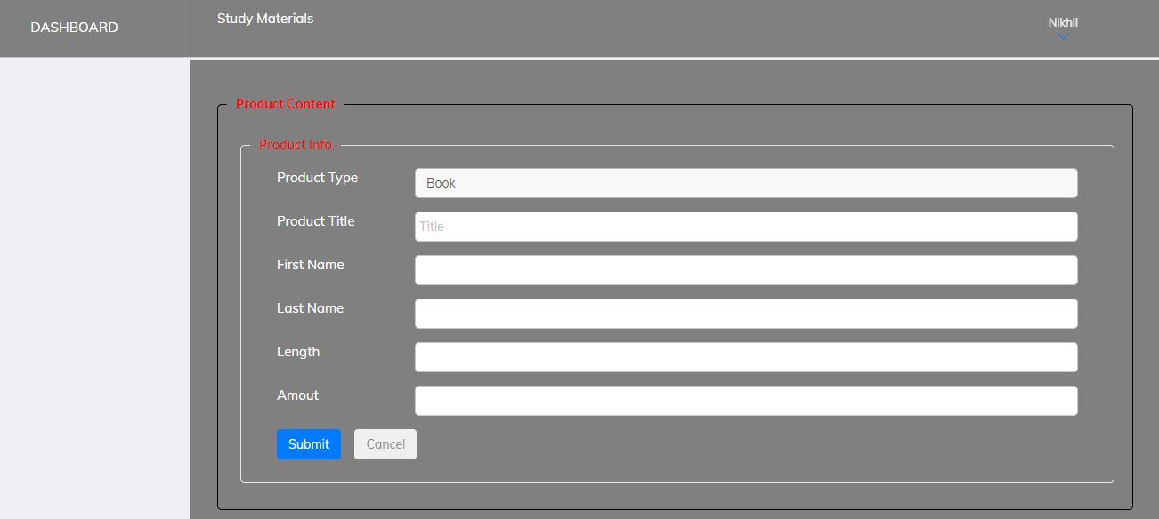

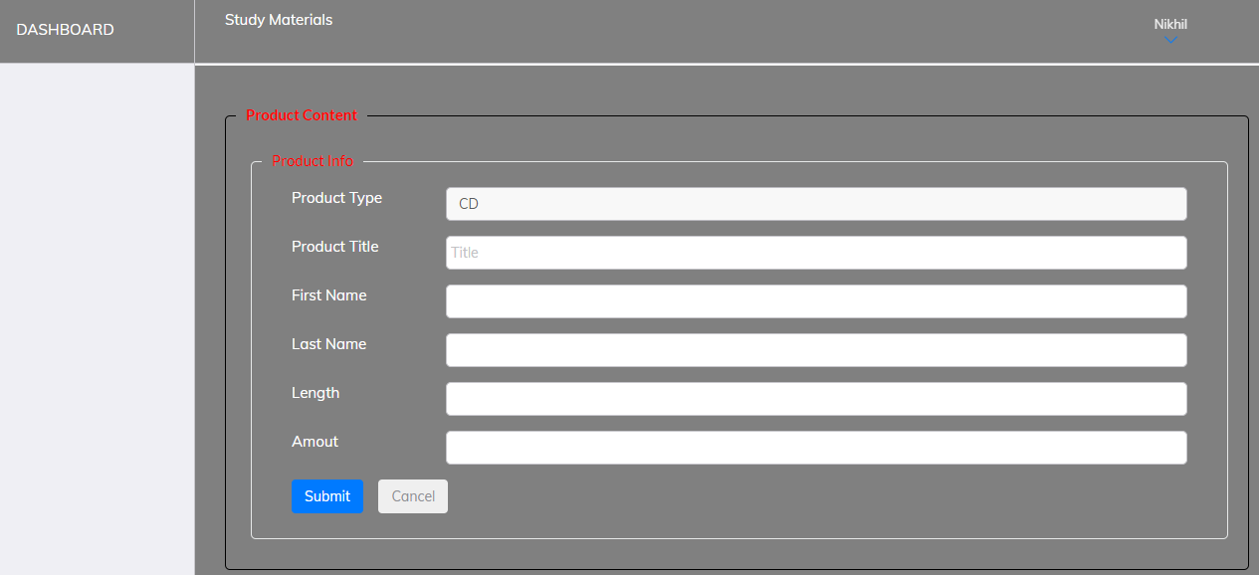

Step 3:

This part is also same as ste 2 but in this part I have add the name and number in create option.

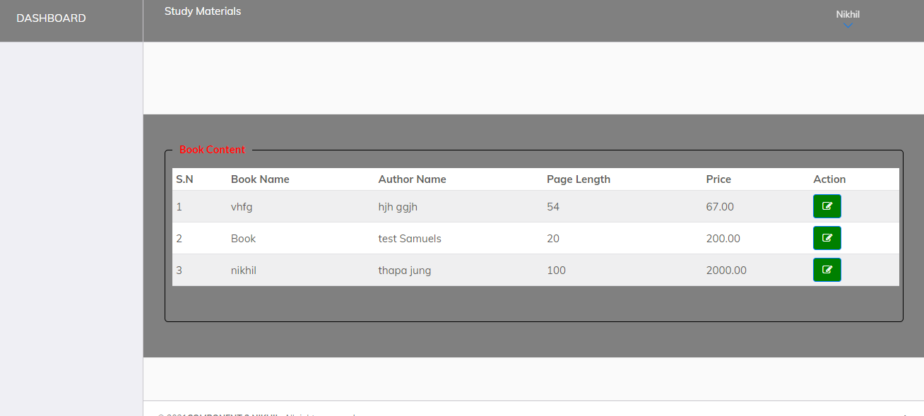

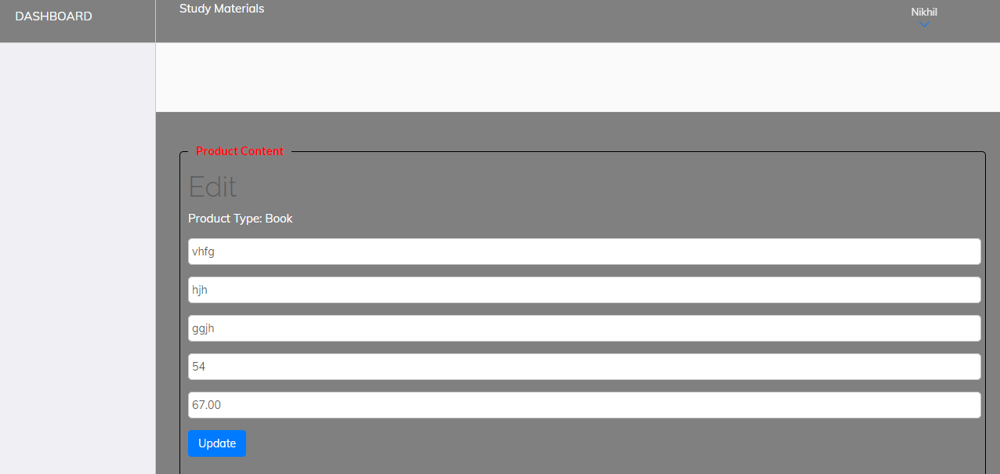

Step 4:

In this part where I add cd table for the project

